1) Finish the training ROI extraction scrip
2) Create 2 ROI training sets for the full library (preprocessed images)
a) 15 ROI’s each
b) Cover the range of imagery types, background types
- How consistent and reliable are human and semantic-segmentation approaches for estimating dreissenid mussel density from underwater imagery?
  - What is the intra-annotator repeatability of manual pixel-level labelling by a trained human?
  - How closely does semantic segmentation agree with human pixel-level labelling?
  - How closely do density estimates derived from semantic segmentation agree with human point-and-click density estimates?
- Which image-based method more closely approximated quadrat-based density estimates?
- Do segmentation models and processing pipelines developed for one underwater imagery survey generalize to independent datasets without retuning?
Workflow:
- Remake map to only show photo
- Extract still image from video
- Pre-process
- Click-counts  - Manual labelling  - Resize labels to match TWS processed image dimensions  - Re-label a subset to assess variability  - Post-process labelled images | - Select training data  - Choose representative images  - Create ROI’s for training that include all variation in classes  - Train TWS  - Post-process segmentation result
- Sensitivity Analysis
  - Artifact suppression (different Gaussian blur sigma in pre-processing)
    - Report % of image area classified as mussel under each sigma level
    - Report Dice coeff (>0.85 = very strong agreement)
- Analyze particles
  - Use minimum size again
- Pixel level comparison of TWS segmentation and manual labels
  - Pixel-wise disagreement rate $Disagreement=\frac{\# px labelled differently}{Total px}$
  - Sorenson-Dice: $\frac{2|A∩B|}{\left|A\right|+|B|}$ (numerator = 2(# of “class 1” pixels labelled the same in both images), denom = sum of pixel in “class 1” in each image)
- Comparison of density from click-counts to:
  - Density from manual labels
  - Density from TWS segmentation
- Compare quadrat density to density from:
  - Manual labelling
  - Point-and-click counting
  - Semantic segmentation
- Run 2,6,7,8,9 on the Buffalo State imagery and compare density only

TWS –
- Test custom feature stack
  - Does it improve result?
  - Does it improve efficiency?

- Probability map – 32 bit
  - Apply threshold
  - Set measurements (mean, min, max)
    - Redirect to probability map (makes results table come from probs)
  - Analyze particles on binary mask
    - Send to ROI manager (can overlay later, save ROI’s etc.)

Apply threshold

4. When you should not rely on this
You should not trust this method if:
- Background ROIs consistently have
  - similar mean and max probabilities to mussels
- Object scores overlap heavily between true/false detections
- Performance depends on fragile numeric thresholds
Those are signs the classifier itself needs improvement, not the post-processing.
No amount of clever ImageJ logic fixes that.

Solving the ROI / Class Label Issue
You asked: "How will I be able to write a macro if I save each class label via the ROI manager, to then label the pruned hyperstack?"
The secret is the Time (T) Slider.
- TWS Logic: When you add a "Class 1" sample, TWS looks at the Frame (T) of that ROI.
- If the ROI is on Frame 1, it extracts features from Image 1.
- If the ROI is on Frame 2, it extracts features from Image 2.
The Problem: When you load your saved ROIs from the ROI Manager, they likely have Position: None or Z: 1. They will all dump onto Frame 1 by default, which is wrong for Images 2, 3, and 4.
The Solution: You need to "deal" the ROIs to the correct frames.

The "ROI Dealer" Macro
Use this simply workflow:
- Open your Final_Hyperstack.
- Open the ROI Manager.
- Load the ROIs for Image 1. (They are already on Frame 1, so do nothing).
- Load the ROIs for Image 2.
  - Run the script below and type "2". It will move all currently selected ROIs to Frame 2.
- Load the ROIs for Image 3. Run script, type "3".
- Load the ROIs for Image 4. Run script, type "4".
Probably junk (This is for adding labels to classes in TWS after using the ROI namer macro)
// Run this ONLY when your TWS window is open and your ROI Manager is full.
count = roiManager("count");

for (i = 0; i < count; i++) {
roiManager("Select", i);
name = Roi.getName();

// Check if it's Class 1 or Class 2 based on our naming convention
if (indexOf(name, "_C1_") >= 0) {
call("trainableSegmentation.Weka_Segmentation.addExample", "0", "0");
} else if (indexOf(name, "_C2_") >= 0) {
call("trainableSegmentation.Weka_Segmentation.addExample", "1", "0");
}
}
print("Feeding Complete: All ROIs transferred to TWS Classes.");
Post process pipeline
- Opening – radius 1 (shape doesn’t matter because 1 pixel)
- Closing – disk – radius 2
- Split by sizes
  - Minimum (user set) to maximum (user set)
  - Maximum (user set) to infinity
- Distance transform watershed on large blobs only
  - Chessknight(5,7,11)
  - 32 bit
  - Normalize weights
  - 8 connected
  - Dynamic = 1
- Erode (to increase the 1px watershed lines for Analyze Particles to work)
- Merge small blobs image with watershed result

Build Labels from ROI pipeline
- Match ROI set to images to be used in TWS

Methods:
Study Site
Skaneateles Lake (42°52'32.3"N 76°23'30.9"W), the second easternmost of the New York State Finger Lakes, is oligotrophic (total phosphorus=5.6 µg/L, chlorophyll-a=0.8 µg/L) relatively narrow (max width = 2.4 km), long (length = 26 km), and deep (max depth = 90 m) with a small watershed to lake area ratio (4.3:1; (Azzaino et al. 2002)). Zebra mussels and quagga mussels were first identified in the lake in 1995 and 2010, respectively (Watkins et al. 2007). Substrates of Skaneateles Lake include a portion of wave impacted channery in the nearshore zone, bedrock and cobble, and clay and silt which supported a diverse array of mollusks prior to dreissenid invasions (Harman 1972). These substrates are typically found in continuous lateral bands around the lake interrupted only by macrophyte growth. During a 1970 survey, a great deal of woody debris was also noted, along with man-made substrates such as piers, docks, pilings, and break walls (Harman 1972), ideal substrate for dreissenid mussel attachment.
Sampling Locations
Field sampling was conducted between July and October 2021 to support evaluation of semantic segmentation for dreissenid mussel surveys and to provide benthic data for lake-wide population estimation. Sampling locations were selected using a stratified transect design to ensure coverage across the lake’s primary depth gradients while ensuring robust latitudinal coverage. Eight east–west transects were established along lines of latitude spanning Skaneateles Lake (Fig. 1). Along each transect, discrete target depths were selected (1, 3, 5, 8, 11, 14, 17, 24, 31, 38, 45, and 52 m). At each site, geographic position was recorded using a Lowrance® HOOK2 chartplotter, and final sampling depth was documented in field logs. Additional sites outside the predefined transects were sampled when environmental conditions (e.g., wind or wave exposure) prevented safe or accurate sampling at planned locations, or when supplemental sampling was required to better represent substrate types encountered during the lake-wide population assessment. Nearshore transects were occasionally adjusted to avoid interference from anthropogenic features such as marinas and public beaches.
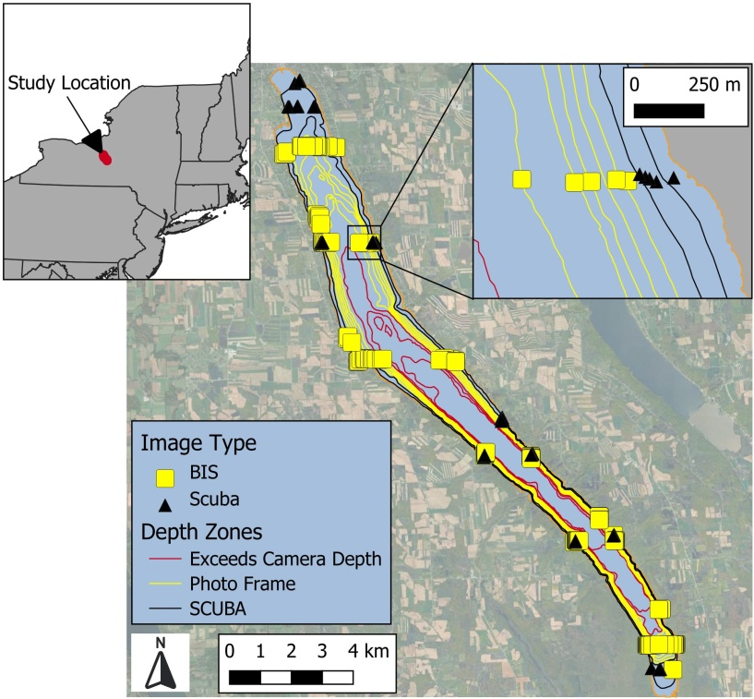
Image Acquisition and Benthic Sample Collection
Underwater video was collected using a SeaLife® Micro 3.0 camera (1080p resolution, 120 frames s⁻¹) with illumination provided by two SeaLife® Sea Dragon 2500F LED dive lights (2500 lumen, 90° underwater beam angle). Video was acquired using two deployment modes: (1) a custom surface-deployed Benthic Imaging System (BIS; Karatayev et al. 2021a) and (2) a diver-operated handheld frame used during scuba-based quadrat sampling. Both systems employed an identical imaging footprint of 21 × 26 cm to ensure consistency between imaging platforms.
Scuba-based sampling was conducted by paired divers at 81 locations. At each site, a transect line was deployed along a fixed latitude within scuba depth limits (<18 m), and divers navigated to target depths using dive computers. One diver placed the handheld imaging frame directly on the substrate while the second recorded video of the framed area. Immediately following video acquisition, all substrate within the frame footprint was collected by the camera operator using a plastic scoop (12 × 7 cm opening) fitted with a 2-mm mesh bag. Sediment was removed to a minimum depth of 4 cm and retained in color-coded mesh bags. Hard substrates within the frame were either collected intact or, in the case of encrusted material on large objects, organisms were scraped free and retained. Upon surfacing, samples were transferred to labeled plastic containers, placed on ice, and transported to the laboratory. Of the 81 scuba sites, video acquisition failed at eight locations due to equipment malfunction, and an additional ten sites were excluded because dense macrophyte growth obscured all benthic organisms. The remaining 65 sites yielded paired video imagery and physical quadrat samples.
In the laboratory, scuba-collected samples were processed on a 1-mm sieve table, and live dreissenid mussels were retained for enumeration. Mussels were spread on a white background and photographed using a Nikon Coolpix AW120 digital camera (snow mode) with supplemental illumination from two SeaLife® Sea Dragon 2500F lights. Mussel counts were obtained using global intensity thresholding to generate binary masks, followed by particle enumeration using the Analyze Particles function in FIJI/ImageJ (Fig. X).
In addition to scuba sampling, video imagery was collected at 219 sites using the surface-deployed BIS. At each location, video recording was initiated at the surface and the BIS was lowered toward the bottom with the aid of boat-mounted sonar (Lowrance® HOOK2). As the frame approached the substrate, descent speed was reduced until contact was made, after which the BIS remained stationary for at least 10 s. Frames extracted immediately prior to bottom contact consistently provided the highest image quality; images collected after contact were frequently degraded by resuspended sediment. Video from 29 BIS sites was excluded due to dense macrophyte cover, suspended sediment, or equipment failure, yielding 190 usable images for subsequent analysis.
Image Pre-processing
Underwater video files were imported into FIJI/ImageJ as image stacks using the FFmpeg import tool (Tomar 2006), such that each stack slice corresponded to an individual video frame. For each video, a single still frame was selected for analysis based on minimal interference from resuspended sediment, macrophytes, and lighting artifacts. The imaging footprint of the BIS was manually cropped from the selected frame using a rectangular region of interest and exported as a JPEG image.
All images were subjected to a single, fixed pre-processing pipeline applied uniformly across the dataset prior to semantic segmentation. Images were first resized to a common spatial scale by resampling the longest image dimension to 1000 pixels while preserving the original aspect ratio. This standardization ensured consistency among pixel-based filters and classifier features. A mild Gaussian blur (σ = 0.6 pixels) was applied globally to suppress compression artifacts and high-frequency noise while preserving biologically relevant structure. Global contrast enhancement was then performed, allowing 0.25% of pixels to saturate, to improve overall separability of image features. Uneven illumination associated with underwater lighting was corrected using a pseudo flat-field approach, implemented via a large-radius Gaussian blur (250 pixels) to remove low-frequency brightness gradients while retaining fine-scale texture. Finally, images were further processed to suppress frame-induced artifacts where the camera frame or BIS was visible. A notch filter was applied in the frequency domain following a fast Fourier transform (FFT) of the image to attenuate strong horizontal and vertical frequency components associated with frame/BIS edges and shadows. The filtered frequency-domain result was spatially constrained to the frame region using a binary border mask and blended with the original image to minimize unintended modification of benthic features.
No image-specific parameter tuning or histogram-based branching was performed. All pre-processing operations and parameter values were held constant across the full image set.
All images were subjected to a single, fixed pre-processing pipeline applied uniformly across the dataset prior to semantic segmentation. Images were first resized to a common spatial scale by resampling the largest image dimension to 1000 pixels while preserving aspect ratio, ensuring consistency among pixel-based filters and classifier features. A mild Gaussian blur (σ = 0.6 pixels) was then applied to suppress compression artifacts and high-frequency noise without attenuating biologically relevant structure. Global contrast enhancement allowing 0.25% of pixels to be fully saturated, was applied to all images to improve overall separability of image features. To correct uneven illumination resulting from underwater lighting, a pseudo flat-field correction was performed using a large-radius blur (250 pixels), targeting low-frequency brightness gradients while preserving fine-scale texture. Finally, images containing a visible camera frame were processed by applying a notch filter to a frequency domain conversion of the target image (Fast-Fourier Transform, FFT), to suppress strong horizontal and vertical signals associated with frame edges and shadows. The FFT result was spatially constrained to the frame region using a binary border mask and blended with the original image to minimize unintended alteration of important mussel features. No image-specific parameter tuning or histogram-based branching was performed, and all pre-processing parameters were held constant across images.
We used Fast-Fourier Transformation (FFT) with a spatially constrained notch filter to suppress strong vertical and horizontal signals produced by the quadrat frame, while preserving overall image brightness and interior texture. To prevent alteration of mussel signals, the FFT-corrected image was blended with the original so that the frequency-domain correction was applied only to regions containing the quadrat frame.
Resize images – The spatial resolution of all images was standardized so that each pixel represented a similar area across images. This ensured that minimum object size thresholds used for counting blobs in manual labels and segmentation results were consistent, avoiding bias in final counts even when initial camera framing or capture resolution varied.
Gaussian blur – convolution of an image using a Gaussian kernel, replacing each pixel with a weighted average of the neighboring pixels. Sigma is the value of the Gaussian distribution at a distance of sigma from the center.
Sensitivity Analysis

Results:
Sensitivity Analysis
- Compression artifact suppression
- TWS feature choices
- TWS maximum sigma
- TWS balance classes
- Training label specification
  - Repeat TWS training by assigning selected pixels to each class, using qualitative assessment to achieve desired result
- Training ROI selection
  - Repeat TWS training using a different set of ROIs and associated class labels
One training set | Multiple training sets
Compression artifact suppression | Training set selection
TWS feature choice
TWS maximum sigma
TWS balance classes
Training repeatability
# of classes
# labels per class

Discussion:
Recording video and extracting still-frames to obtain imagery from deep underwater is common practice (citations), providing an affordable way to access environments inhospitable to human exploration. A limitation of this approach is that extracted frames inherit characteristics of the video compression process. Specifically, the H.264 (MPEG-4 AVC) codec used by the SeaLife Micro 3.0 camera encodes imagery using 16 × 16 pixel macroblocks, which can introduce subtle block-level intensity discontinuities. These artifacts are generally imperceptible under normal viewing conditions but can become visible following contrast enhancement, representing non-biological texture that could potentially confound semantic segmentation.
To minimize their influence, all images were processed using a standardized pipeline that included mild, global Gaussian smoothing (radius = 0.6 px) prior to contrast enhancement, which suppressed sharp macroblock boundaries while preserving biologically relevant edges and shapes. In this study, video was recorded at 1080p and 120 fps to maximize the likelihood of extracting a still image immediately upon bottom contact, before a sediment plume formed from the camera frame impact. While this strategy improved the chances of capturing an unobscured frame, it also increased the prominence of macroblock artifacts.
Our sensitivity analysis indicated that the chosen preprocessing effectively mitigated any negative impacts of these artifacts on semantic segmentation. For future deployments, we recommend prioritizing maximum video resolution (4K @ 30 fps or the highest available), constraining ISO to the lowest feasible range, using standard color and soft sharpness settings, and avoiding in-camera contrast enhancement or auto white balance. Extracting still frames in a lossless format (e.g., PNG) would further reduce concerns regarding compression artifacts. Although macroblock artifacts associated with H.264 compression are unavoidable, the combined use of these settings and preprocessing steps minimizes their potential influence on semantic segmentation results.

